8-Week TRANSFORMATION Starts 10/15!

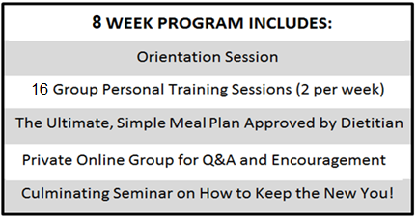

Boost your fitness level. Change your eating habits. Lose body fat percentage. Have fun doing it!
We've now run 6 Transformation Programs and the results speak for themselves.

Our incredible 8-week program was formed under the guidance of 60+ years of combined fitness experience between expert trainers Scott, David Y., David M. in conjunction with our registered dietitian, Amy M. Our "Transformers" lose weight, gain lean muscle,
and work hard as a team to reach their goals!
SAVE $200 with PROMO CODE: FALL (Regularly $785)

Our next Orientation for our next 8-week session is 10/15/17. Sessions will run from 10/23 – 12/16.
We make the personal training session times work for everyone!
If you are interested in joining the program and have questions,
email Scott and Leslie at tonezone4me@gmail.com.

More details:
Who is the Transformation Program for? 1) Those who are seeking to lose weight in a healthy, sustainable way. 2) Those who may not need to lose weight, but are seeking to tone up their bodies by losing body fat. Both have been extremely successful in our program. In fact, during one of our sessions, the person who lost the highest body fat percentage lost 35 lbs, while the person who lost the second highest body fat percentage only lost a few pounds because she simply didn’t need to lose any more. Both participants transformed their bodies incredibly based on their own specific goals!
Orientation includes: Body fat analysis, dietary information, education on your metabolism, step-by-step instructions for how the program will work, and tips for success.
Training sessions will be scheduled throughout the entire week for your choosing. Early morning, mid-day and evening and weekend times will be available. Times will be determined at orientation based on participants’ schedules.

