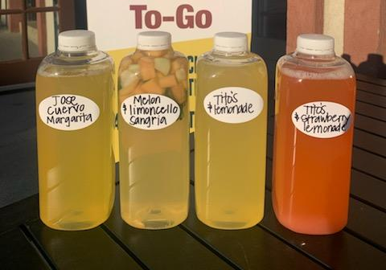
COCKTAILS
TYPE | 32oz | 64oz
Tito’s & Lemonade | $17 | $30
Absolut Bloody Mary | $17 | -
Jose Cuervo Margarita | $23 | $40
Razz Arnold Palmer | $17
Tequila Sunrise | $17
Lynchburg Lemonade | $17
Green Tea | $17
Tito’s & Strawberry Lemonade | $17
Melon & Limoncello Sangria | $18
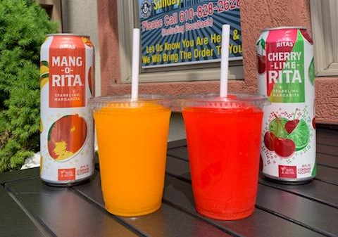
SLUSHIES
TYPE |  | 16oz
Rita’s Mango |  | $6
Rita’s Black Cherry Lime |  | $6
Rita’s Lemonade |  | $6
Rita’s Strawberry |  | $6
Rita’s Mango |  | $6

