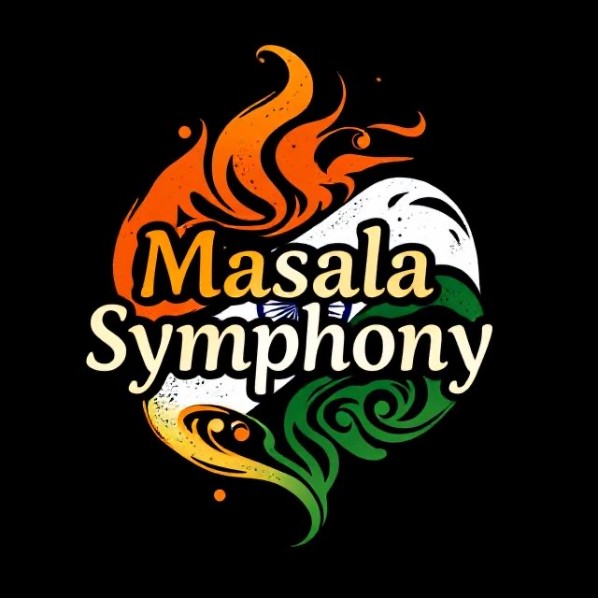
Holiday Feast Menu (24Th Dec – 31st Dec)
$30.95 Per Guest

Course 1 & 2
Soups (Select One)
• Gobi Gajar Shorba – A comforting roasted cauliflower and carrot soup, delicately spiced with aromatic Indian herbs.
• Palak Kale Shorba – A nourishing spinach and kale soup, gently spiced and simmered for a smooth, earthy flavor.

Appetizers (Select One)
• Vegetable Samosa – Crispy golden pastry filled with spiced potatoes, peas, and aromatic Indian seasonings.
• Vegetable Spring Roll – Light and crispy rolls stuffed with seasoned mixed vegetables, fried to a golden crunch.
• Tandoori Chicken – Yogurt marinated chicken infused with traditional spices and roasted to perfection in the tandoor oven.

Courses 3 & 4
Entrées (Select One)
• Shahi Mushroom Matar – Tender mushrooms and green peas cooked in a rich, creamy cashew-based royal gravy.
• Palak Paneer – Creamy spinach curry with tender cubes of Indian cottage cheese.
• Chicken Tikka Masala – Juicy grilled chicken simmered in a rich, spiced tomato-cream sauce.
• Baingan Gosht Ki Sabzi – Tender Lamb and smashed eggplant cooked with aromatic spices, finished with grated hard-boiled egg.
• Mussels Curry – Coastal-style mussels gently cooked in rich coconut gravy with aromatic spices.
• Shrimp Bhuna – Juicy shrimp cooked with onions and bell peppers with aromatic spices.
Breads (Select One)
• Butter Naan – Soft, golden naan with a luscious butter finish
• Garlic Naan – Warm Indian flatbread with aromatic garlic and a buttery finish.

Course 5 – Dessert
Gulab Jamun with Vanilla Ice Cream – Warm, soft milk dumplings soaked in fragrant rose-cardamom syrup, served with a scoop of creamy vanilla ice cream.

